**Pseudo-code:**

For i to size – 1

Grab point 1 & point 2 and calculate distance(pt1,pt2) initialize result struct

For j (j=i+1) to size-1

Distance = dis (pt[i],pt[j])

If(distance < result.distance)

Result.distance = distance

Clear vector which store the shortest pair of points

Push pt[i],pt[i+1] to vector

else if (distance == result.distance)

push finded pairs to vector

End for

End for

**Asymptotic Analysis of run time:**

For the out for loop it iterates through all elements of the points array who has n elements, so it will execute n times. Inner loop go through element from index i + 1 to 0, so it will go through 1 times, 2 times, … n-1 times. When out loop go through n times, total times for inner loops execution is 1 + 2 +3 + … + n-1 = (1 + n -1)*n/2 = n^2/2.

When n -> infinite, T(n) = n^2/2, which divider 2 is not import, due to the n^2 domain it. n^2/2 < n^2, so T(n) = O(n^2). The time complexity of Brute force would be O(n^2/2).

**Empirical analysis and plotting:**

|  |  |  |  |  |  |
| --- | --- | --- | --- | --- | --- |
| NumInputs(100)\times | 1st | 2nd | 3rd | 4th | 5th |
| Runtime | 0.000159s | 0.000149s | 0.000155s | 0.000170s | 0.000148s |
| -- | 6th | 7th | 8th | 9th | 10th |
| -- | 0.000162s | 0.000150s | 0.000175s | 0.000149s | 0.000149s |

Average: 0.000157s

|  |  |  |  |  |  |
| --- | --- | --- | --- | --- | --- |
| NumInputs(1000)\times | 1st | 2nd | 3rd | 4th | 5th |
| Runtime | 0.014481s | 0.014158s | 0.014113s | 0.014336s | 0.014153s |
| -- | 6th | 7th | 8th | 9th | 10th |
| -- | 0.014154s | 0.013996s | 0.013928s | 0.013956s | 0.013961s |

Average: 0.014248s

|  |  |  |  |  |  |
| --- | --- | --- | --- | --- | --- |
| NumInputs(10000)\times | 1st | 2nd | 3rd | 4th | 5th |
| Runtime | 1.424536s | 1.451141s | 1.554845s | 1.533729s | 1.411581s |
| -- | 6th | 7th | 8th | 9th | 10th |
| -- | 1.592131s | 1.407556s | 1.409005s | 1.589402s | 1.412498s |

Average: 1.4786474s

|  |  |  |  |  |  |
| --- | --- | --- | --- | --- | --- |
| NumInputs(100000)\times | 1st | 2nd | 3rd | 4th | 5th |
| Runtime | 141s | 142s | 140s | 140s | 142s |
| -- | 6th | 7th | 8th | 9th | 10th |
| -- | 139s | 140s | 141s | 141s | 142s |

Average: 140.8s

**Plot:**

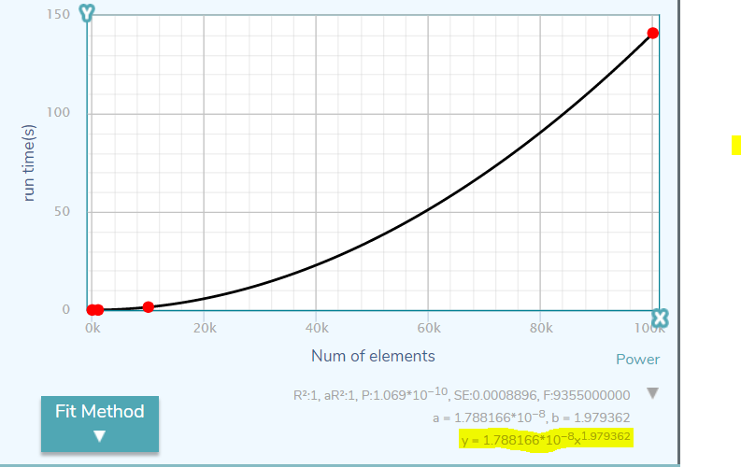

After we plug the points into the curve fitting tools, I get this curve and whose formula almost same as y= x^2.